

**PROJECT**

**TRIVIA QUIZ RESPONSIVE WEB DESIGN USING HTML5 AND JQUERY**

Group :

Name : Fadhilah Jasman (1710010029)

Kevin Fabian Mahardika (1710010054)

Class : 3SC5

CEP CCIT

FAKULTAS TEKNIK UNIVERSITAS INDONESIA

2018

**PROJECT ON**

*Trivia Quiz Responsive Web Design Using HTML5 and JQuery*

**Developed by**

Name:

1. Fadhilah Jasman (1710010029)
2. Kevin Fabian Mahardika (1710010054)



**Trivia Quiz Responsive Web Design Using HTML5 and JQuery**

Batch Code : 3SC5

Start Date : October 5th 2018  
End Date : November 1st 2018

Name of Faculty : Mr. Fachran Nazarullah, S.Kom.

Names of Developer :

1. Fadhilah Jasman (1710010029)
2. Kevin Fabian Mahardika (1710010054)

Date of Submission : November 1st 2018

**CERTIFICATE**

This is to certify that this report titled “ **Trivia Quiz Responsive Web Design Using HTML5 and Jquery**” embodies the original work done by **Fadhilah Jasman** and **Kevin Fabian Mahardika**.Project in partial fulfillment of their course requirement at NIIT.

Coordinator:

Mr. Fachran Nazarullah, S.Kom.



**ACKNOWLEDGEMENT**

Praise thanks God, give thanks or God love and grace for us, who has bestowed all His blessing, so the author can finish Project entitled Trivia Quiz Responsive Web Design Using HTML5 and JQuery. Blessing and greetings may be bestowed upon Prophet Muhammad and his followers.

Writer have benefited a lot from the feedback and suggestions given to us by Mr. Fachran Nazarullah, S.Kom. and other faculty members. Writer make this project to fulfill our assignment.

Writer make this project with see the basic of School Information System and make it with our own style.

Writer know this paper is far from perfection. Writer hope if writer friend and writer faculty give any comment and suggestion to make this paper better than before.

Writer also said thank you to:

1. Beloved parents who have educated and guided and helped author both morally and materially, so the authors can finish this project.
2. Our Friends who give many idea, spirit and comment to our project.

If the writer made a mistake in writing the application of this School Information System, Writer ask forgive to all reader and listener of this paper.

Depok, October 5th 2018

b

**SYSTEM ANALYSIS**

**System Summary**:

Based on the developments, the number and the types of instructional media that exist today very much and varied either in the form of media ones intentionally designed or not designed specifically but can be utilized within learning activities.

Use of instructional media in this Trivia Quiz Responsive Web Design Using HTML5 and JQuery to be able helps in providing that experience meaningful and also to train the ability of the user, this application is expected to facilitate users to understand something and bring a positive impact.

The proposed application system for Trivia Quiz Responsive Web Design Using HTML5 and JQuery will be used by users:

Implemented in Web systems intended to address quiz so that achieve a desired expectations is:

•       Improve brain quickly and efficiently

•       increase the insight and knowledge

Trivia Quiz Responsive Web Design Using HTML5 and JQuery is intended to performance to the brain so that the performance be fast, effective and efficient so as to provide more satisfaction to users, with a faster response brain and efficiently higher for answer Trivia Quiz Responsive Web Design Using HTML5 and JQuery.

**INTRODUCTION**

**System Process**:

Trivia Quiz Responsive Web Design Using HTML5 and JQuery is intended to performance to the brain so that the performance be fast, effective and efficient so as to provide more satisfaction to users, with a faster response brain and efficiently higher for answer Trivia Quiz Responsive Web Design Using HTML5 and JQuery.Trivia Quiz Responsive Web Design Using HTML5 and JQuery this simulation answer online test questions the rules for you must answer question: This question consists of 2 level,This simulation consists of 10 questions,This question consists of 3 option.

**AKTIVITIES LIST**

**System Process**:

|  |  |  |  |  |  |
| --- | --- | --- | --- | --- | --- |
| NO | Activity Description | Planned Date  of Completion | Actual Date | Responsibility | Remarks |
| 1 | Create Layout using HTML and CSS | October 10th 2018 | May 24th 2018 | Fadhilah |  |
| 2 | Create Content and Image Web | October 8th 2018 | October 9th 2018 | Kevin |  |
| 3 | Create Form | October 6th 2018 | October 20th 2018 | Fadhilah |  |
| 4 | Create Validation using JavaScript | October 6th 2018 | October 20th 2018 | Fadhilah |  |
| 5 | Create Effect using JQuery | October 6th 2018 | October 20th 2018 | Kevin |  |
| 6 | Create Meta Tag | October 6th 2018 | October 20th 2018 | Kevin |  |
| 7 | Responsive Web Design Using HTML5 and JQuery | October 6th 2018 | October 20th 2018 | Fadhilah |  |
| 8 | Make a Paper | October 28th 2018 | October 29th 2018 | Fadhilah |  |
| 9 | Power Point | October 28th 2018 | October 29th 2018 | Fadhilah |  |

**HTML PAGES**

**System Process**:

1. **Form Login**

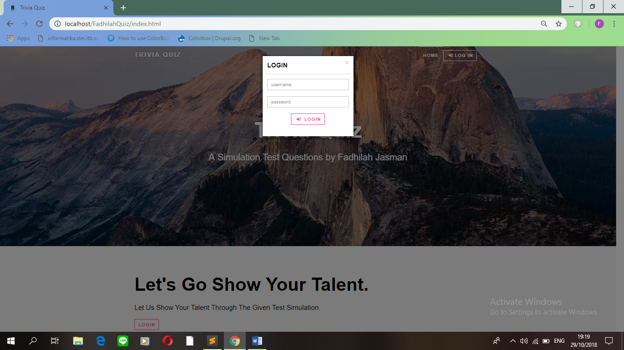

Login form is a requirement to be able to follow the question of quiz in this web. If not fill out login form means you cannot enter to fill question about quiz.

\

sssssssssss

**HTML PAGES**

**System Process**:

1. **Form Main Menu**

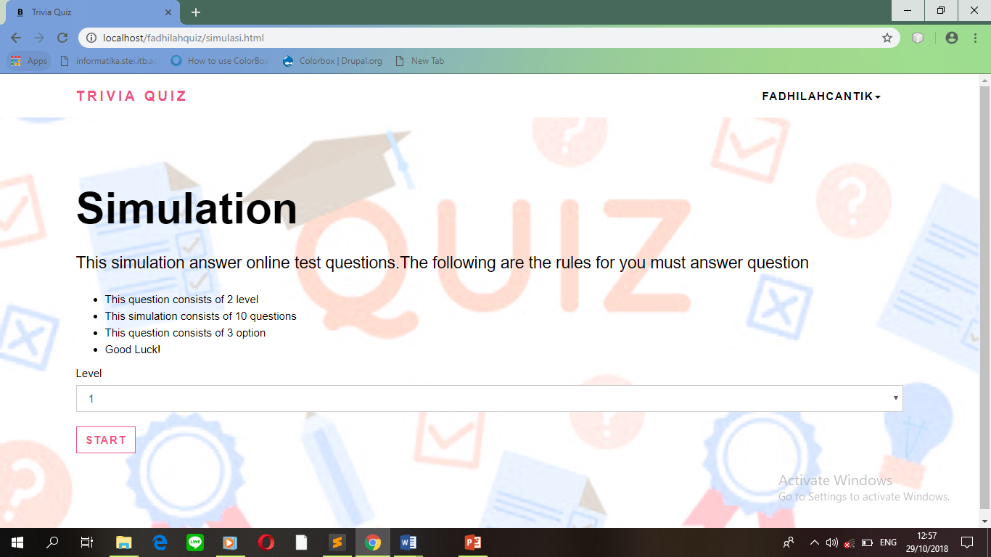

Main menu there are two options that is option, start and instruction. If you select start then you will go to two options that is level 1 and level 2, and Instruction then there will be instruction to work this quiz question.

**DESIGN INTERFACE**

**HTML PAGES**

**System Process**:

1. **Form Level 1**

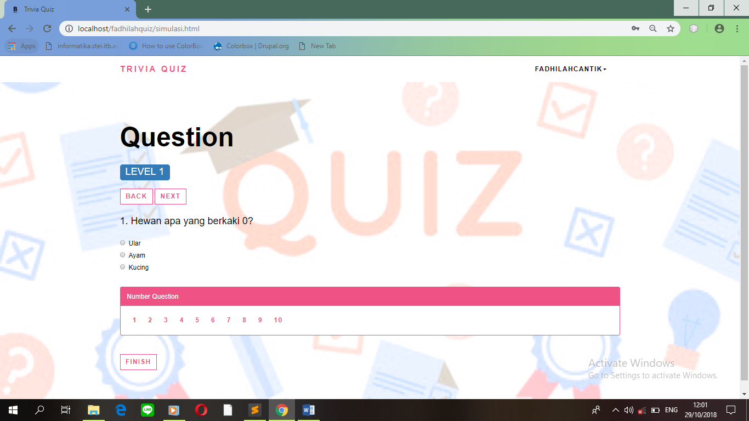

Level 1 in it consists of 10 questions with three option, and users are required to answer.



**System Process**:

1. **Form Level 2**

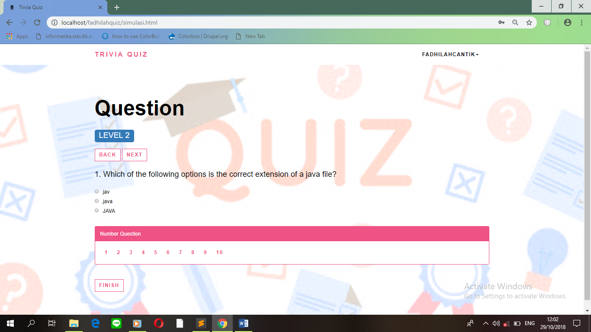

In level 2 also consists of 10 questions, with three options and the user is required to answer.

**HTML PAGES**

**HTML PAGES**

**System Process**:

1. **Form Score**

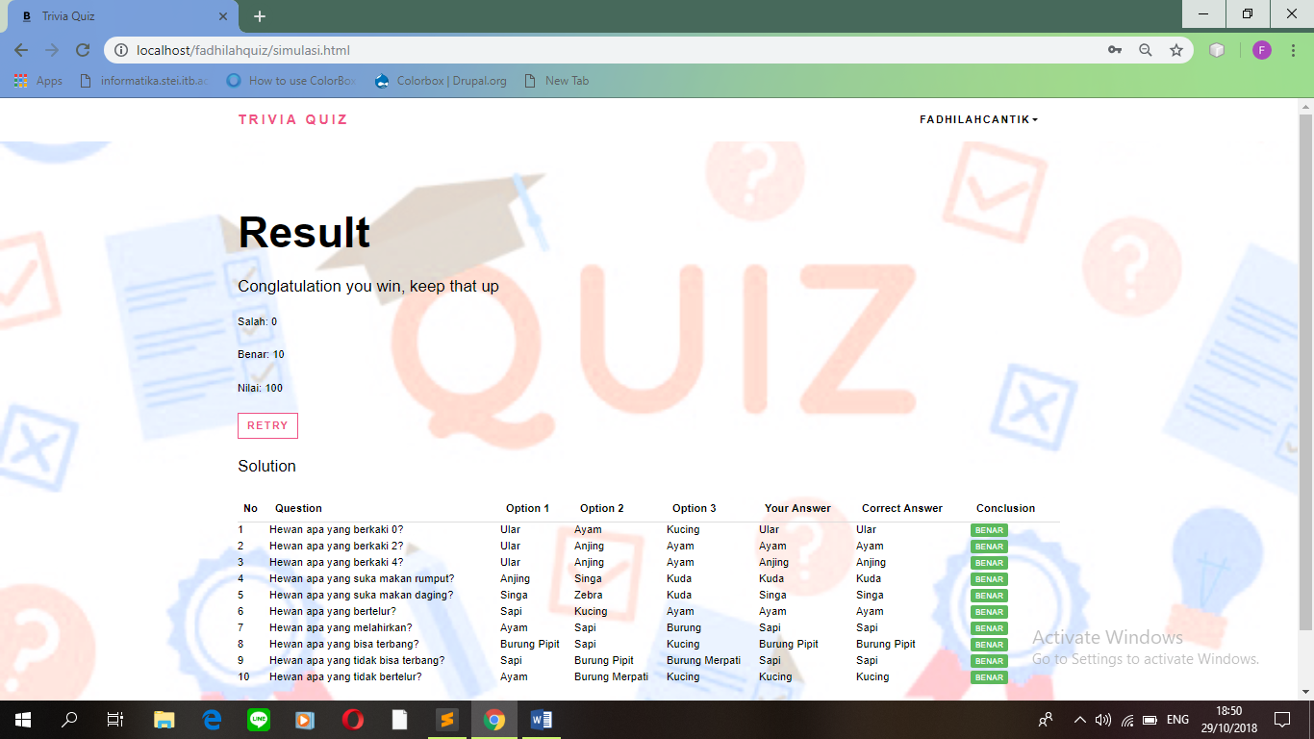

The results obtained from a question that has been user answered.

**HTML PAGES**

**System Process**:

1. **Form Lose**

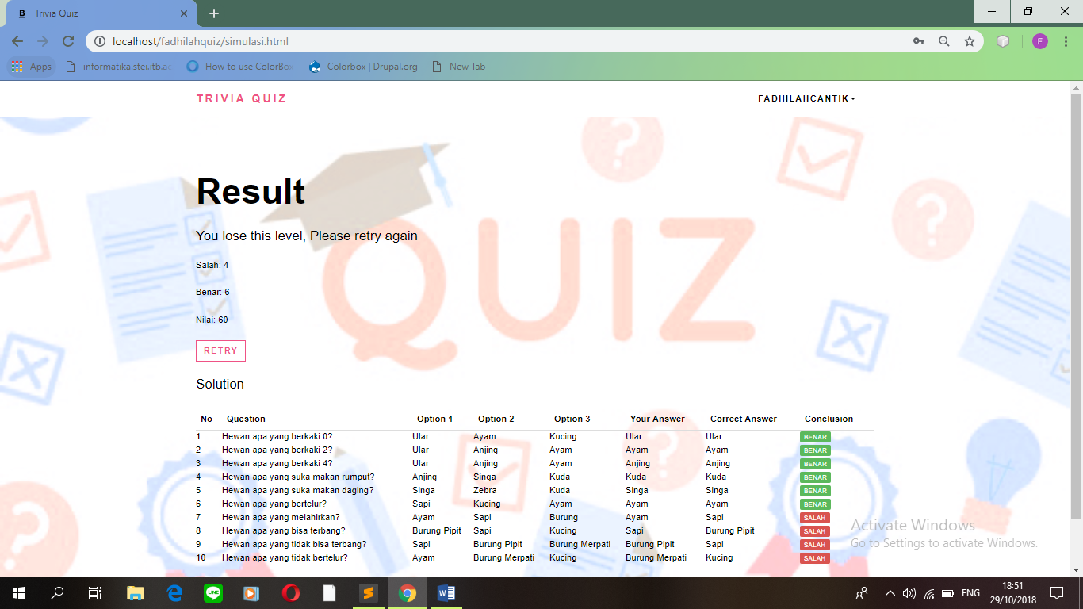

If the user gets a value smaller than 60, it will exit the lose form and the user can not continue to the next level and the user will repeat again about the previous quiz.

**HTML PAGES**

**System Process**:

1. **Form Win**



If the user can get the value above 60, it will appear win form and the user has managed to answer all these quiz questions.

**HTML PAGES**

**System Process**:

1. **Form Option**



There are two options, whether the user wants to repeat the quiz question or return to menu early and logout trivia quiz.

**CONFIGURATION**

**Hardware : -** PC intel core i7, 8gb ram

* PC intel core i3, 4gb ram, 500gb hdd
* PC AMD a9, 4gb ram, 500 gb hdd

**Operating System :** Microsoft Windows 10

**Software :**  - Sublime Text 3 and Google Chrome

|  |  |  |
| --- | --- | --- |
| **PROJECT FILE DETAILS** | | |
| **S.No** | **File Name** | **Remarks** |
| 1. | Trivia Quiz Responsive Web Design Using HTML5 and JQuery | Requirements Project WAP, there are HTML5,JQuery,JavaScript,and Bootstrap |

\

sssssssssss